**INSTAGRAM USER ANALYTICS**

**Project Description:**

The project is about to analyze the user interaction and engagement in a Instagram platform and provide some valuable insights to the product team that help business to grow by taking some decisions like giving rewards to top loyal users, organizing a contest to increase the user, etc.

**Approach:**

We first perform the Marketing Analysis such as: Loyal user reward, Inactive user engagement, Contest winner declaration, Hashtag Research, Ad campaign Launch that helps to attract more users and then find out Investor Metrics like User engagement, Bot and fake accounts to help the investor for better decisions.

**Marketing Analysis:**

**Loyal User Reward:** Reward the most loyal user

Task: find the top 5 oldest users in Instagram?

Query:

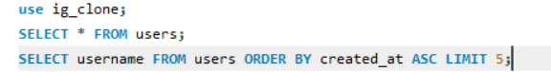

First, I find all users, then search for top user by sorting the column ‘created_at’ in ascending order and Iimit of 5 to get 5 oldest user.

Output:

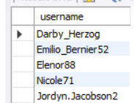

**Inactive User Engagement:** To encourage the inactive users

Task: Find users who never posted a photo single time?

Query:



First we JOIN the users table with photos table, then find the users whose photos.id is NULL , i.e users who does not having a photo.id has not posted a single pic.

Output:

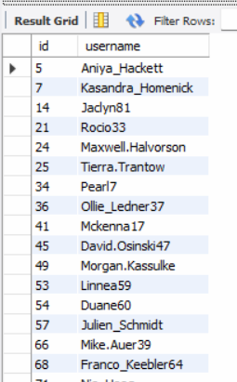 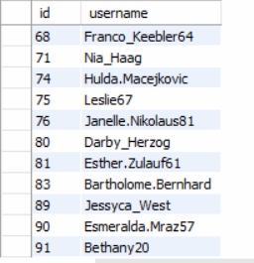

**Contest Winner Declaration:** The team wants to declare a user with most likes on a single photo in a contest as a Contest Winner.

Task: Find the user details having maximum likes in a single photo to award him a winner?

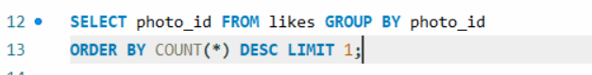

First, I want find the ‘photo_id’ which get the maximum likes using COUNT(*) functions in a likes table .

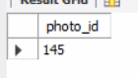



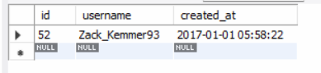

Then I find user details of user who posted that photo by using WHERE condition which helps to find out the user_id of user.

**Hashtag Research:** Most popular hashtags to reach to the most people

Task: Identify the top 5 hashtags of the platform.

Query



Output:

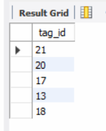

Query:



Output:

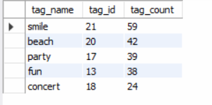

First, I find out top 5 tag_id from photo_tags table and then find out the tag_name corresponding to ‘tag.id’ by using JOINS on tags and photo_tags table and identify the top 5 tags with also a tags count.

**Ad campaign Launch:** Best day to launch any ad by a team.

Task: Find the day of week when most user registered on Instagram and that day will be best for launching any Ad.

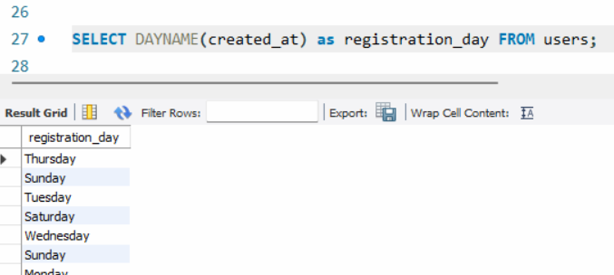

First, we find the days at which users registers on Instagram.

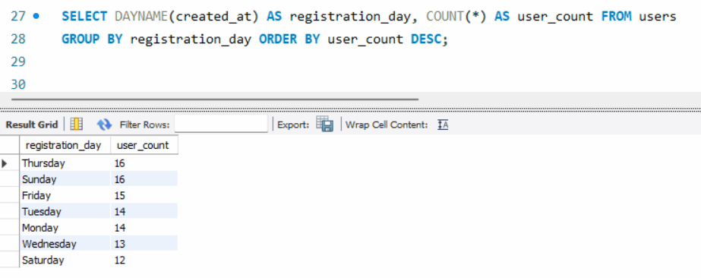

Then add a column ‘user_count’ to count the days when most user registers on Instagram.

Brand should launch any Ads On Thursday and Sunday.

**Investor Metrics:**

**User engagement:** Investor wants users who are still active and their posting behavior.

Task: Avg number of posts posted by active users i.e. , avg post per user and total number of posts divide by total number of users.

Query:



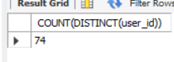

First, I find the total number of active users.

Query:



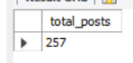

Then I find the total number of posts in Instagram.

Query:



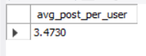

Avg photos posted by user in Instagram.

Query:



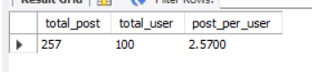

Total number of post in Instagram / Total number of users as post_per_user.

**Bots & fake account:** Investor wants to knowplatform has occupied by bots and fake accounts.

Task: User who likes every photo on a Instagram considered as a Suspicious user.

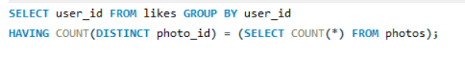

Find the users (user_id) from ‘likes’ table who likes every photo (photo_id) by equalizing count of likes done with count of photos posted on Instagram.

**Tech_stack Used:**

For this project we used **SQL** language for data analysis.

We use **MYSQL** as our RDBMS which used to store and manipulate data.

**Insights:**

* Instagram has mostly active users but still 25 percent users are still unactive on which team can focus to encourage them.
* Less than 50 % users liking the photos posted on Instagram Contest.
* 80 % of photos are posted with Hashtags.
* Thursday and Sunday are important days to organize any contest, launch Ads.
* On an average 3 photos are posted by active users in Instagram.
* 10 % users can consider to be suspicious users on Instagram.

**Results:**

We successfully find out the fake accounts to address the unusual behavior.

We find out best days to check the Instagram account to get latest updates.

**Drive link:**

[**https://drive.google.com/drive/folders/1f_DL85t8Xqn_-093R2HUVLLgYlIeBhgi?usp=drive_link**](https://drive.google.com/drive/folders/1f_DL85t8Xqn_-093R2HUVLLgYlIeBhgi?usp=drive_link)